Gmail bot

**Proxy**

It uses 911.re proxy app

Need to do:

I want to add sock 5 proxies

**Creating accounts Requirements**

Phone verification:

atm it uses: <https://en.sms-online.pro/>

Fake ID: random creates ID with fake names

Random password

**Forward emails**

Need to do:

The bot needs to forward emails to another email

**Multithreads**

Need to do:

Make the bot multithreads

**Need UI**

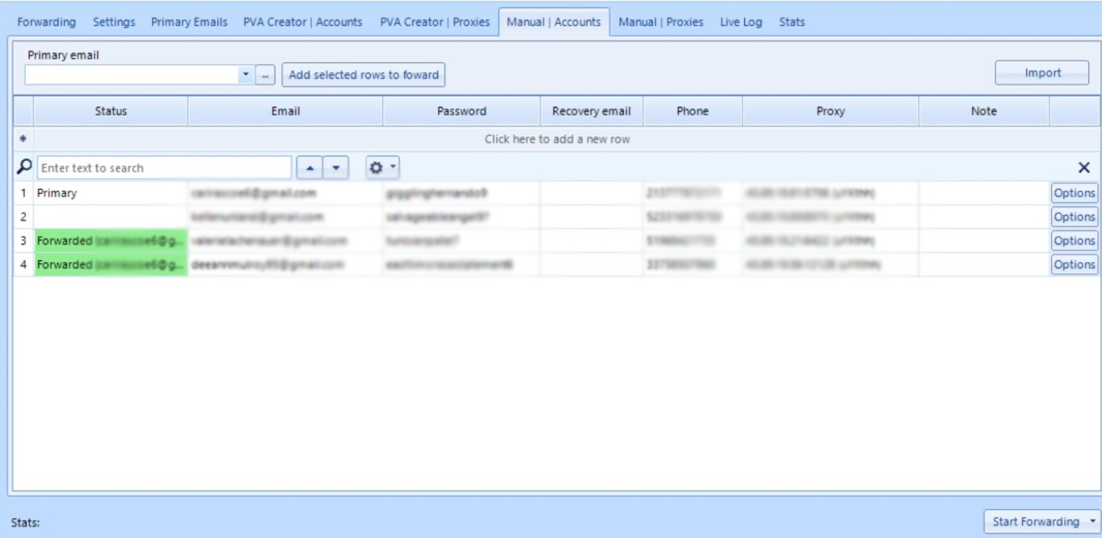

**Save data in a csv**

When the bot creates gmail accounts, it saves

name

last name

birthday

recovery email (if the user wants to add it or not)

phone number recovery used on creation (these numbers are from third party sms verification)

on creation google put the number used for verification in the field phone number recovery, the use can remove this number, keep the number or replace it with his own phone number

**License**

I want to make the bot rent, so I need a license system